District convention is coming sooner than you think! Camp Luther and Jesus Our Savior Preschool/afterschool program are the recipients of the in-gathering. Below is a list of their needs and wants. Our generosity assists them in carrying out their respective ministries.
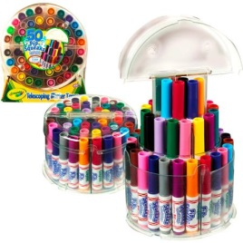
Jesus Our Savior:
- Forever postage stamps
- Crayola Pip-Squeaks Markers (50 count in a telescoping tower)
- 5 oz. Dixie paper cups (found at Walmart)
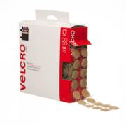
- Microwavable paper bowls – NOT Styrofoam
- Crayola Jumbo Triangular shape Crayons
- Scotch Thermal Laminating Pouches-letter size
- Religious foam craft kits
- White and colored cardstock paper – 8 ½ x 11
- Velcro Dots
- Colored copy paper
- $$$ - to purchase milk, cheese, yogurt, and fresh fruits/veggies; tuition assistance
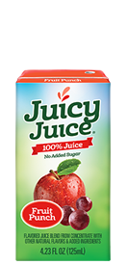
- Nutritious snacks – Peanut butter, Ritz crackers, Graham crackers, REAL Juice boxes, Applesauce and fruit cups, granola bars, Cereals (like Waffle Crisp, Cinnamon Toast Crunch Fruit Loops, Cheerios)
- Gift cards – Walmart, Target, Sam’s Club, Hobby Lobby or Staples
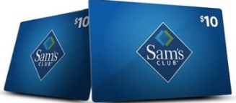

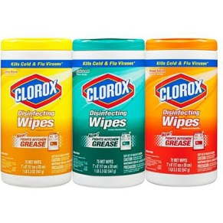
Camp Luther:
- Clorox/Lysol cleaning wipes
- Forever postage stamps
- White and colored cardstock paper – 8 ½ x 11
- SINGLE ply toilet paper
- Water/sand play toys
- XLarge Rectangular Aluminum roasting pans – 18”x13-5/16”x2-5/8”
- New travel size Shampoo, body wash, soap, toothpaste, deodorant, toothbrushes
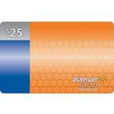
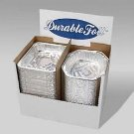
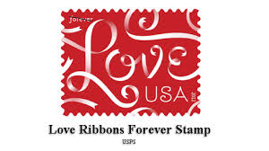
- Gift cards – Amazon, Menards, Walmart, Hy-Vee, Super Saver, Didiers Grocery, Nebraska Fuel Stations

