Pillowcase Pattern
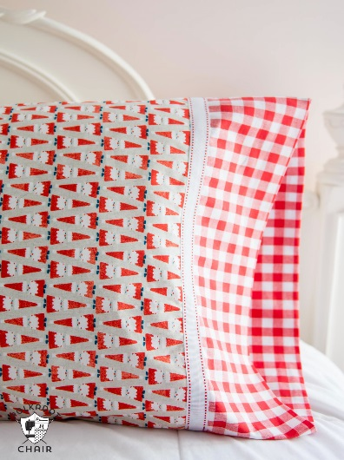
This Photo by Unknown Author is licensed under CC BY-NC-ND
Fabric Requirements: (Standard Size Pillowcase)
Main Piece: 27” x 41” (3/4 yard)
Border Piece: 10” x 41” (1/3 yard)
Accent Strip: 3” x 41” (1/8 yard)

Directions:
- Cut pieces as follows:
  - Main piece – 27” x 41”
  - Border Piece – 10” x 41”
  - Accent Strip – 3” x 41”
- Lay 10” boarder piece face up on the table
- Lay main piece of pillowcase face up, lined up with border piece. All raw edges patch at the top.
- Press the 3” trim piece in half the long way (so it is 1 ½ inches wide) and lay face up on top of the main piece. All raw edges on the top.
- Roll the main fabric from the bottom up and then fold the border piece up to the top and pin all of the raw edges together.
- Stitch ½ inch along the edge. You now have a tube of fabric. Turn the tube inside out. Your pillowcase is nearly finished with no raw edges and a completed finished edge on front and back.
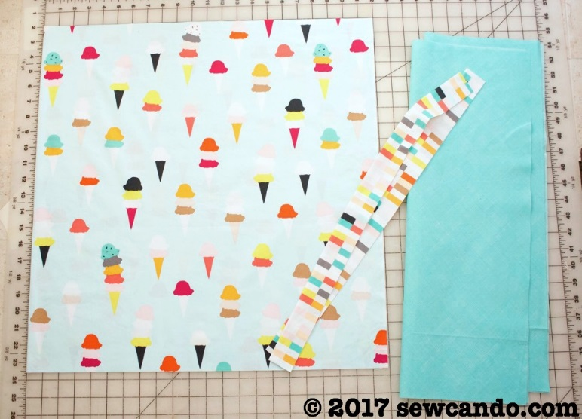
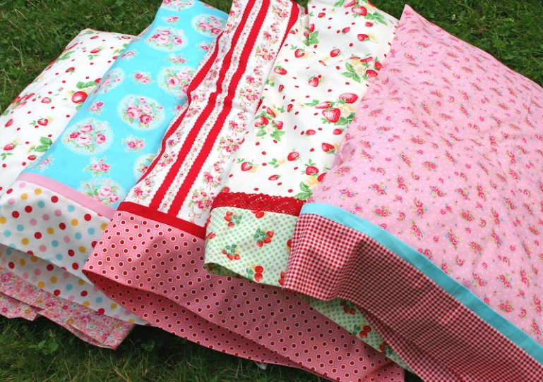
- French Seam finish: With the pillowcase right side out, place wrong sides together and sew the side and bottom using an ½ inch seam. Next, turn the pillowcase inside out, press, and sew the side and bottom again using ¼ inch seam.

